**CSC 3101- Spring Summer 2016**

**Lab Assignment 1**

1. (30)

P= A+B

Q= A+B

Output=A∙B

|  |  |  |
| --- | --- | --- |
| Inputs | Intermediate Values | Output |
| A B | P Q |  |
| 0 0 | 0 0 | 0 |
| 0 1 | 1 1 | 1 |
| 1 0 | 1 1 | 1 |
| 1 1 | 1 1 | 1 |

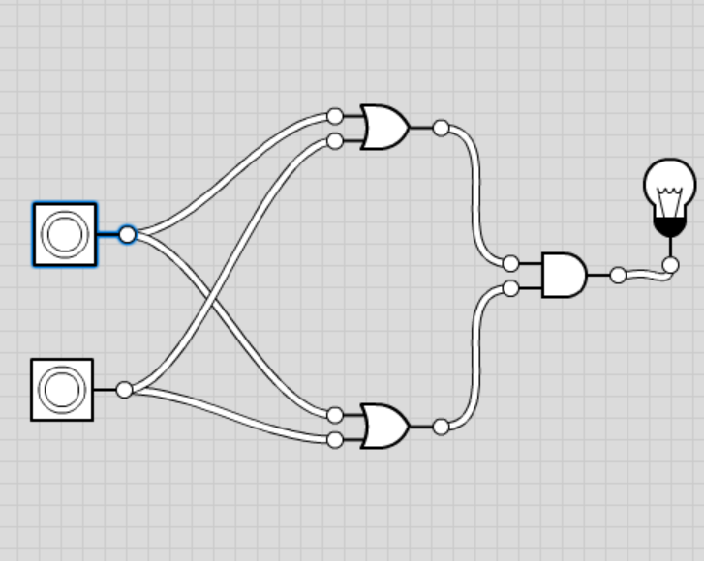

1. (30)

P=A∙B

Q= A∙B

Output = P+Q

|  |  |  |
| --- | --- | --- |
| Inputs | Intermediate Values | Output |
| A B | P Q |  |
| 0 0 | 0 0 | 0 |
| 0 1 | 0 0 | 0 |
| 1 0 | 0 0 | 0 |
| 1 1 | 1 1 | 1 |

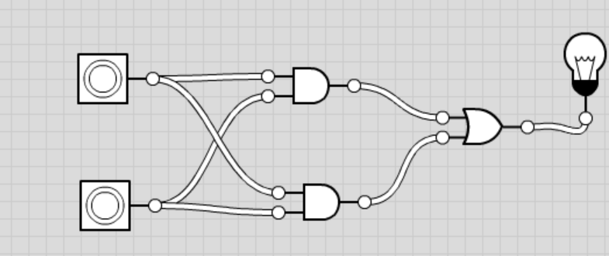

∙

1. (40)

R=!(A∙B∙C)

S= A∙B∙C

T= A+B+C

U=R∙S

V=!(S∙T)

W=U+V

X=U

Y=W

Z=V

|  |  |
| --- | --- |
| Inputs | Output |
| A B C | X Y Z |
| 0 0 0 | 0 1 1 |
| 0 0 1 | 0 1 1 |
| 0 1 0 | 0 1 1 |
| 0 1 1 | 0 1 1 |
| 1 0 0 | 0 1 1 |
| 1 0 1 | 0 1 1 |
| 1 1 1 | 0 0 0 |

